**Health**

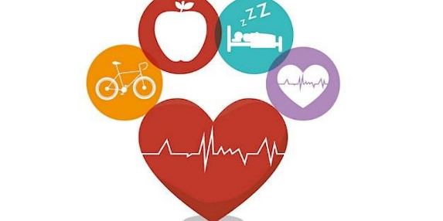This information is a **summary**.

This means it has been **shorted** to help keep it **simple**.

This is what different Party’s think should happen with **health.**

**Health services** means things like:

* Doctors, nurses, therapists and other people who work in health
* Hospitals, pharmacies, doctors clinics.
* Disability supports
* Medication

|  |  |
| --- | --- |
| Labour | Make newer hospitals and health centres.  More doctors and nurses.  More money for medicines. People don’t have to pay to get their medicine at the pharmacy.  Mental Health: 5 Tips to Improve your Mental Wellbeing | by Valeria  Rodrigues | Insumo | MediumFree visits to the doctor for kids  New Services for mental health.  Support Māori Health. |
| National  NZ National Party (@NZNationalParty) / X | Have **more nurses**   * Pay nurses **more money** * Have more nurses from **overseas** * Student nurses have to **stay in New Zealand** for longer (not go work in another country).   Teach more **doctors**.  Mental Health: 5 Tips to Improve your Mental Wellbeing | by Valeria  Rodrigues | Insumo | Medium**More** **help** for people with **cancer**.  More money for **mental health** (emotions, how you feel, and thoughts).    A red x on a black background  Description automatically generatedNo **extra health services for Māori**.  National wants the **same** healthcare for everybody.  National plan to **stop having** the Māori health authority. |
| Green | Have **more** health services.  More money for the **Māori Health**.  Pay health workers more money.  Pay for more **new medicines**.  Make health services **respect** all people.   * Some people find it hard to get good health care, e.g. disabled people, Māori, Pasifika, and people who don’t speak much English.   Work **with disabled people** to make **decisions** about the support they want. |
| ACT  ACT New Zealand - Wikipedia | ACT want to make it easier to use **Private Hospitals.**   * This is where you **pay** to go to the doctors or hospital. * It means people have more **choice**.   Mental Health: 5 Tips to Improve your Mental Wellbeing | by Valeria  Rodrigues | Insumo | MediumHave a separate organisation for **mental health** (emotions, thoughts, how you feel).    Change how medicine is **approved** (allowed to be used) and **paid for** in New Zealand.  **No special** services for **Māori**.    ACT things everyone should be **treated the same**. No one gets special treatment.  This means no **extra** health services for **Māori** or **Pasifika** people. |
| Te Pātāi Māori | More money for Māori health    Māori people can get health care early (not have to wait a long time). |

You can **read more** about things on the Party Websites:

|  |  |
| --- | --- |
|  | <https://www.labour.org.nz/> |
| National  NZ National Party (@NZNationalParty) / X | <https://www.national.org.nz/> |
|  | <https://www.greens.org.nz/> |
| ACT  ACT New Zealand - Wikipedia | <https://www.act.org.nz/> |
| Te Pātāi Māori | <https://www.maoriparty.org.nz/> |