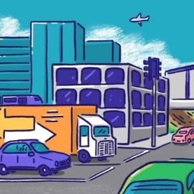**Transport**

This information is a **summary**.

This means it has been **shorted** to help keep it **simple**.

This is what different Party’s think should happen with **transport, roads and getting around.**

|  |  |
| --- | --- |
| Labour | Build more roads.  Build more big motorways, and roads between cities.    Keep public transport cheap (not cost much money).  **$**  More trains and buses in Auckland and Wellington. |
| National  NZ National Party (@NZNationalParty) / X | Build **lots more roads.**  Build more roads and motorways **between cities**.  **Stop** people getting a discount (paying less money) if their car is better for the environment.  Have **more** places to charge an **electric car**.  Stop the discount (cheaper prices) on public transport (buses, trains and ferry’s).  Stop the plan to build trains in Auckland. Add more buses.  **Stop** the plan for Wellingtons **roads** and **public transport.**  Make the **Wellington trains better**. |
| Green | Focus on **public transport, bikes and walking** NOT roads and cars.  Build more **pathways** for **walking** and **riding bikes**.    More **trains** and **buses**.  Make public transport **free** for more people.    Get **electric buses** that are better for the **environment**.  When there are **roadworks**, make a **plan** for how people will get around on **public transport**. |
| ACT  ACT New Zealand - Wikipedia | Increase the speed limit. Let cars drive faster.  Stop Hand Images - Free Download on Freepik**Stop** people getting a **discount** (paying less money) if their car is better for the environment.  **Stop** the plan to build **trains** in Auckland.  **Stop** the plan for **Wellingtons roads** and **public transport**. |

You can **read more** about things on the Party Websites:

|  |  |
| --- | --- |
|  | <https://www.labour.org.nz/> |
| National  NZ National Party (@NZNationalParty) / X | <https://www.national.org.nz/> |
|  | <https://www.greens.org.nz/> |
| ACT  ACT New Zealand - Wikipedia | <https://www.act.org.nz/> |
|  |  |